21.8: a) The total number of electrons on each sphere equals the number of protons.

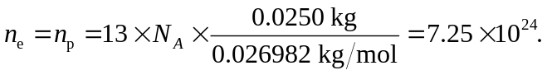
b) For a force of 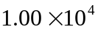 N to act between the spheres,
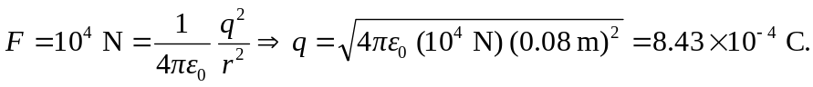
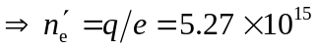
c) 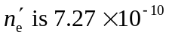 of the total number.

